https://www.exam-answer.com/microsoft/az-900

Question #1Topic 1
DRAG DROP -
Your company intends to subscribe to an Azure support plan.
The support plan must allow for new support requests to be opened.
Which of the following are support plans that will allow this? Answer by dragging the correct option from the list to the answer area.
Select and Place:
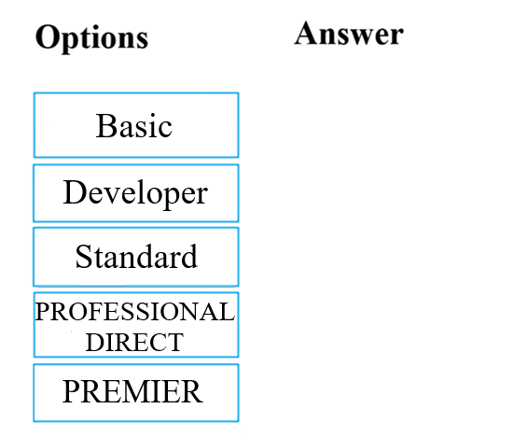
Hide Solution Discussion 108
Correct Answer: 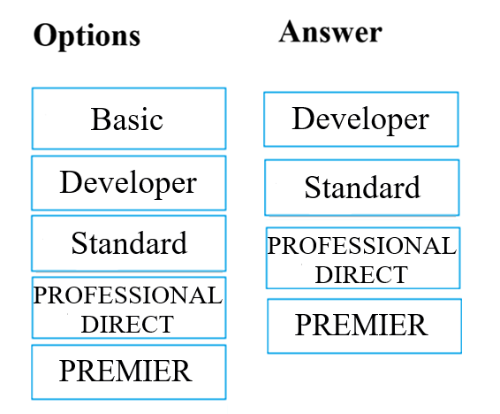
References:
https://azure.microsoft.com/en-us/support/plans/
Question #2Topic 1
Your company has datacenters in Los Angeles and New York. The company has a Microsoft Azure subscription.
You are configuring the two datacenters as geo-clustered sites for site resiliency.
You need to recommend an Azure storage redundancy option.
You have the following data storage requirements:
✑ Data must be stored on multiple nodes.
✑ Data must be stored on nodes in separate geographic locations.
✑ Data can be read from the secondary location as well as from the primary location
Which of the following Azure stored redundancy options should you recommend?
- A. Geo-redundant storage
- B. Read-only geo-redundant storage Most Voted
- C. Zone-redundant storage
- D. Locally redundant storage
Hide Solution Discussion 31
Correct Answer: B 🗳️
RA-GRS allows you to have higher read availability for your storage account by providing ג€read onlyג€ access to the data replicated to the secondary location. Once you enable this feature, the secondary location may be used to achieve higher availability in the event the data is not available in the primary region. This is an
ג€opt-inג€ feature which requires the storage account be geo-replicated.
References:
https://docs.microsoft.com/en-us/azure/storage/common/storage-redundancy https://docs.microsoft.com/en-us/azure/storage/common/storage-redundancy-grs#read-access-geo-redundant-storage
Community vote distribution
B (100%)
Question #3Topic 1
Note: The question is included in a number of questions that depicts the identical set-up. However, every question has a distinctive result. Establish if the solution satisfies the requirements.
Your company's Azure subscription includes a Basic support plan.
They would like to request an assessment of an Azure environment's design from Microsoft. This is, however, not supported by the existing plan.
You want to make sure that the company subscribes to a support plan that allows this functionality, while keeping expenses to a minimum.
Solution: You recommend that the company subscribes to the Professional Direct support plan.
Does the solution meet the goal?
- A. Yes Most Voted
- B. No Most Voted
Hide Solution Discussion 71
Correct Answer: B 🗳️
References:
https://azure.microsoft.com/en-gb/support/plans/
Community vote distribution
B (74%)
A (26%)
Question #4Topic 1
Note: The question is included in a number of questions that depicts the identical set-up. However, every question has a distinctive result. Establish if the solution satisfies the requirements.
You are tasked with deploying Azure virtual machines for your company.
You need to make use of the appropriate cloud deployment solution.
Solution: You should make use of Software as a Service (SaaS).
Does the solution meet the goal?
- A. Yes
- B. No Most Voted
Hide Solution Discussion 28
Correct Answer: B 🗳️
Community vote distribution
B (100%)
Question #5Topic 1
Note: The question is included in a number of questions that depicts the identical set-up. However, every question has a distinctive result. Establish if the solution satisfies the requirements.
You are tasked with deploying Azure virtual machines for your company.
You need to make use of the appropriate cloud deployment solution.
Solution: You should make use of Platform as a Service (PaaS).
Does the solution meet the goal?
- A. Yes
- B. No Most Voted
Hide Solution Discussion 22
Correct Answer: B 🗳️
Community vote distribution
B (100%)
Question #6Topic 1
Note: The question is included in a number of questions that depicts the identical set-up. However, every question has a distinctive result. Establish if the solution satisfies the requirements.
You are tasked with deploying Azure virtual machines for your company.
You need to make use of the appropriate cloud deployment solution.
Solution: You should make use of Infrastructure as a Service (IaaS).
Does the solution meet the goal?
- A. Yes Most Voted
- B. No
Hide Solution Discussion 29
Correct Answer: A 🗳️
Community vote distribution
A (100%)
Question #7Topic 1
Your developers have created 10 web applications that must be host on Azure.
You need to determine which Azure web tier plan to host the web apps. The web tier plan must meet the following requirements:
✑ The web apps will use custom domains.
✑ The web apps each require 10 GB of storage.
✑ The web apps must each run in dedicated compute instances.
✑ Load balancing between instances must be included.
✑ Costs must be minimized.
Which web tier plan should you use?
- A. Standard Most Voted
- B. Basic
- C. Free
- D. Shared
Hide Solution Discussion 163
Correct Answer: B 🗳️
Standard offers 50 GB of storage space, while Basic only gives 10 GB.
References:
http://azure.microsoft.com/en-us/pricing/details/websites/
Community vote distribution
A (70%)
B (26%)
4%
Question #8Topic 1
Note: The question is included in a number of questions that depicts the identical set-up. However, every question has a distinctive result. Establish if the solution satisfies the requirements.
You are planning to migrate a company to Azure. Each of the company's numerous divisions will have an administrator in place to manage the Azure resources used by their respective division.
You want to make sure that the Azure deployment you employ allows for Azure to be segmented for the divisions, while keeping administrative effort to a minimum.
Solution: You plan to make use of several Azure Active Directory (Azure AD) directories.
Does the solution meet the goal?
- A. Yes
- B. No Most Voted
Hide Solution Discussion 26
Correct Answer: B 🗳️
Community vote distribution
B (100%)
Question #9Topic 1
Your developers have created a portal web app for users in the Miami branch office. The web app will be publicly accessible and used by the Miami users to retrieve customer and product information. The web app is currently running in an on-premises test environment.
You plan to host the web app on Azure.
You need to determine which Azure web tier plan to host the web app. The web tier plan must meet the following requirements:
✑ The website will use the miami.weyland.com URL.
✑ The website will be deployed to two instances.
✑ SSL support must be included.
✑ The website requires 12 GB of storage.
✑ Costs must be minimized.
Which web tier plan should you use?
- A. Standard Most Voted
- B. Basic
- C. Free
- D. Shared
Hide Solution Discussion 18
Correct Answer: A 🗳️
References:
http://azure.microsoft.com/en-us/documentation/articles/azure-subscription-service-limits/
Community vote distribution
A (100%)
Question #10Topic 1
Note: The question is included in a number of questions that depicts the identical set-up. However, every question has a distinctive result. Establish if the solution satisfies the requirements.
Your company is planning to migrate all their virtual machines to an Azure pay-as-you-go subscription. The virtual machines are currently hosted on the Hyper-V hosts in a data center.
You are required make sure that the intended Azure solution uses the correct expenditure model.
Solution: You should recommend the use of the elastic expenditure model.
Does the solution meet the goal?
- A. Yes
- B. No Most Voted
Hide Solution Discussion 36
Correct Answer: B 🗳️
Community vote distribution
B (100%)

Question #11Topic 1
Note: The question is included in a number of questions that depicts the identical set-up. However, every question has a distinctive result. Establish if the solution satisfies the requirements.
Your company is planning to migrate all their virtual machines to an Azure pay-as-you-go subscription. The virtual machines are currently hosted on the Hyper-V hosts in a data center.
You are required make sure that the intended Azure solution uses the correct expenditure model.
Solution: You should recommend the use of the scalable expenditure model.
Does the solution meet the goal?
- A. Yes
- B. No Most Voted
Hide Solution Discussion 20
Correct Answer: B 🗳️
Community vote distribution
B (100%)
Question #12Topic 1
Note: The question is included in a number of questions that depicts the identical set-up. However, every question has a distinctive result. Establish if the solution satisfies the requirements.
Your company is planning to migrate all their virtual machines to an Azure pay-as-you-go subscription. The virtual machines are currently hosted on the Hyper-V hosts in a data center.
You are required make sure that the intended Azure solution uses the correct expenditure model.
Solution: You should recommend the use of the operational expenditure model.
Does the solution meet the goal?
- A. Yes Most Voted
- B. No
Hide Solution Discussion 18
Correct Answer: A 🗳️
Community vote distribution
A (100%)
Question #13Topic 1
Note: The question is included in a number of questions that depicts the identical set-up. However, every question has a distinctive result. Establish if the solution satisfies the requirements.
You are required to deploy an Artificial Intelligence (AI) solution in Azure.
You want to make sure that you are able to build, test, and deploy predictive analytics for the solution.
Solution: You should make use of Azure Cosmos DB.
Does the solution meet the goal?
- A. Yes
- B. No Most Voted
Hide Solution Discussion 18
Correct Answer: B 🗳️
Community vote distribution
B (100%)
Question #14Topic 1
Note: The question is included in a number of questions that depicts the identical set-up. However, every question has a distinctive result. Establish if the solution satisfies the requirements.
Your company's Active Directory forest includes thousands of user accounts.
You have been informed that all network resources will be migrated to Azure. Thereafter, the on-premises data center will be retired.
You are required to employ a strategy that reduces the effect on users, once the planned migration has been completed.
Solution: You plan to sync all the Active Directory user accounts to Azure Active Directory (Azure AD).
Does the solution meet the goal?
- A. Yes Most Voted
- B. No
Hide Solution Discussion 29
Correct Answer: A 🗳️
Community vote distribution
A (100%)
Question #15Topic 1
Note: The question is included in a number of questions that depicts the identical set-up. However, every question has a distinctive result. Establish if the solution satisfies the requirements.
You are required to deploy an Artificial Intelligence (AI) solution in Azure.
You want to make sure that you are able to build, test, and deploy predictive analytics for the solution.
Solution: You should make use of Azure Machine Learning Studio.
Does the solution meet the goal?
- A. Yes
- B. No
Hide Solution Discussion 16
Correct Answer: A 🗳️
Community vote distribution
A (100%)
Question #16Topic 1
Note: The question is included in a number of questions that depicts the identical set-up. However, every question has a distinctive result. Establish if the solution satisfies the requirements.
Your company's infrastructure includes a number of business units that each need a large number of various Azure resources for everyday operation.
The resources required by each business unit are identical.
You are required to sanction a strategy to create Azure resources automatically.
Solution: You recommend that the Azure API Management service be included in the strategy.
Does the solution meet the goal?
- A. Yes
- B. No Most Voted
Hide Solution Discussion 30
Correct Answer: B 🗳️
Community vote distribution
B (100%)
Question #17Topic 1
Note: The question is included in a number of questions that depicts the identical set-up. However, every question has a distinctive result. Establish if the solution satisfies the requirements.
Your company's infrastructure includes a number of business units that each need a large number of various Azure resources for everyday operation.
The resources required by each business unit are identical.
You are required to sanction a strategy to create Azure resources automatically.
Solution: You recommend that management groups be included in the strategy.
Does the solution meet the goal?
- A. Yes
- B. No
Hide Solution Discussion 19
Correct Answer: B 🗳️
Community vote distribution
A (100%)
Question #18Topic 1
Note: The question is included in a number of questions that depicts the identical set-up. However, every question has a distinctive result. Establish if the solution satisfies the requirements.
Your company's infrastructure includes a number of business units that each need a large number of various Azure resources for everyday operation.
The resources required by each business unit are identical.
You are required to sanction a strategy to create Azure resources automatically.
Solution: You recommend that the Azure Resource Manager templates be included in the strategy.
Does the solution meet the goal?
- A. Yes
- B. No
Hide Solution Discussion 19
Correct Answer: A 🗳️
Community vote distribution
A (100%)
Question #19Topic 1
Note: The question is included in a number of questions that depicts the identical set-up. However, every question has a distinctive result. Establish if the solution satisfies the requirements.
You are tasked with deploying a critical LOB application, which will be installed on a virtual machine, to Azure.
You are informed that the application deployment strategy should allow for a guaranteed availability of 99.99 percent. You need to make sure that the strategy requires as little virtual machines and availability zones as possible.
Solution: You include two virtual machines and one availability zone in your strategy.
Does the solution meet the goal?
- A. Yes
- B. No
Hide Solution Discussion 23
Correct Answer: B 🗳️
References:
https://docs.microsoft.com/en-us/azure/availability-zones/az-overview
Community vote distribution
B (100%)
Question #20Topic 1
Note: The question is included in a number of questions that depicts the identical set-up. However, every question has a distinctive result. Establish if the solution satisfies the requirements.
You are tasked with deploying a critical LOB application, which will be installed on a virtual machine, to Azure.
You are informed that the application deployment strategy should allow for a guaranteed availability of 99.99 percent. You need to make sure that the strategy requires as little virtual machines and availability zones as possible.
Solution: You include one virtual machine and two availability zones in your strategy.
Does the solution meet the goal?
- A. Yes
- B. No
Hide Solution Discussion 28
Correct Answer: B 🗳️
References:
https://docs.microsoft.com/en-us/azure/availability-zones/az-overview
Community vote distribution
B (100%)

Question #21Topic 1
Note: The question is included in a number of questions that depicts the identical set-up. However, every question has a distinctive result. Establish if the solution satisfies the requirements.
You are tasked with deploying a critical LOB application, which will be installed on a virtual machine, to Azure.
You are informed that the application deployment strategy should allow for a guaranteed availability of 99.99 percent. You need to make sure that the strategy requires as little virtual machines and availability zones as possible.
Solution: You include two virtual machines and two availability zones in your strategy.
Does the solution meet the goal?
- A. Yes Most Voted
- B. No Most Voted
Hide Solution Discussion 66
Correct Answer: A 🗳️
References:
https://docs.microsoft.com/en-us/azure/availability-zones/az-overview
Community vote distribution
A (88%)
12%
Question #22Topic 1
Note: The question is included in a number of questions that depicts the identical set-up. However, every question has a distinctive result. Establish if the solution satisfies the requirements.
Your company's developers intend to deploy a large number of custom virtual machines on a weekly basis. They will also be removing these virtual machines during the same week it was deployed. Sixty percent of the virtual machines have Windows Server 2016 installed, while the other forty percent has Ubuntu Linux installed.
You are required to make sure that the administrative effort, needed for this process, is reduced by employing a suitable Azure service.
Solution: You recommend the use of Microsoft Managed Desktop.
Does the solution meet the goal?
- A. Yes
- B. No
Hide Solution Discussion 14
Correct Answer: B 🗳️
Community vote distribution
B (100%)
Question #23Topic 1
Note: The question is included in a number of questions that depicts the identical set-up. However, every question has a distinctive result. Establish if the solution satisfies the requirements.
Your company's developers intend to deploy a large number of custom virtual machines on a weekly basis. They will also be removing these virtual machines during the same week it was deployed. Sixty percent of the virtual machines have Windows Server 2016 installed, while the other forty percent has Ubuntu Linux installed.
You are required to make sure that the administrative effort, needed for this process, is reduced by employing a suitable Azure service.
Solution: You recommend the use of Azure Reserved Virtual Machines (VM) Instances.
Does the solution meet the goal?
- A. Yes
- B. No
Hide Solution Discussion 11
Correct Answer: B 🗳️
Community vote distribution
B (100%)
Question #24Topic 1
Note: The question is included in a number of questions that depicts the identical set-up. However, every question has a distinctive result. Establish if the solution satisfies the requirements.
Your company's developers intend to deploy a large number of custom virtual machines on a weekly basis. They will also be removing these virtual machines during the same week it was deployed. Sixty percent of the virtual machines have Windows Server 2016 installed, while the other forty percent has Ubuntu Linux installed.
You are required to make sure that the administrative effort, needed for this process, is reduced by employing a suitable Azure service.
Solution: You recommend the use of Azure DevTest Labs.
Does the solution meet the goal?
- A. Yes
- B. No
Hide Solution Discussion 18
Correct Answer: A 🗳️
Community vote distribution
A (100%)
Question #25Topic 1
Your company has virtual machines (VMs) hosted in Microsoft Azure. The VMs are located in a single Azure virtual network named VNet1.
The company has users that work remotely. The remote workers require access to the VMs on VNet1.
You need to provide access for the remote workers.
What should you do?
- A. Configure a Site-to-Site (S2S) VPN.
- B. Configure a VNet-toVNet VPN.
- C. Configure a Point-to-Site (P2S) VPN. Most Voted
- D. Configure DirectAccess on a Windows Server 2012 server VM.
- E. Configure a Multi-Site VPN
Hide Solution Discussion 23
Correct Answer: C 🗳️
A Point-to-Site (P2S) VPN gateway connection lets you create a secure connection to your virtual network from an individual client computer.
References:
https://docs.microsoft.com/en-us/azure/vpn-gateway/vpn-gateway-about-vpngateways
Community vote distribution
C (100%)
Question #26Topic 1
Note: The question is included in a number of questions that depicts the identical set-up. However, every question has a distinctive result. Establish if the solution satisfies the requirements.
You have been informed by your superiors of the company's intentions to automate server deployment to Azure. There is, however, some concern that administrative credentials could be uncovered during this process.
You are required to make sure that during the deployment, the administrative credentials are encrypted using a suitable Azure solution.
Solution: You recommend the use of Azure Information Protection.
Does the solution meet the goal?
- A. Yes
- B. No Most Voted
Hide Solution Discussion 26
Correct Answer: B 🗳️
Community vote distribution
B (100%)
Question #27 Topic 1
Note: The question is included in a number of questions that depicts the identical set-up. However, every question has a distinctive result. Establish if the solution satisfies the requirements.
You have been informed by your superiors of the company's intentions to automate server deployment to Azure. There is, however, some concern that administrative credentials could be uncovered during this process.
You are required to make sure that during the deployment, the administrative credentials are encrypted using a suitable Azure solution.
Solution: You recommend the use of Azure Multi-Factor Authentication (MFA).
Does the solution meet the goal?
- A. Yes
- B. No
Hide Solution Discussion 13
Correct Answer: B 🗳️
Community vote distribution
B (100%)
Question #28Topic 1
DRAG DROP -
The company would like to develop a cloud solution by making use of Azure Government. Azure Government can only be used by certain types of clients to develop cloud solutions.
Which of the following are the types of customers that can make use of Azure Government in this situation? Answer by dragging the correct option from the list to the answer area.
Select and Place:
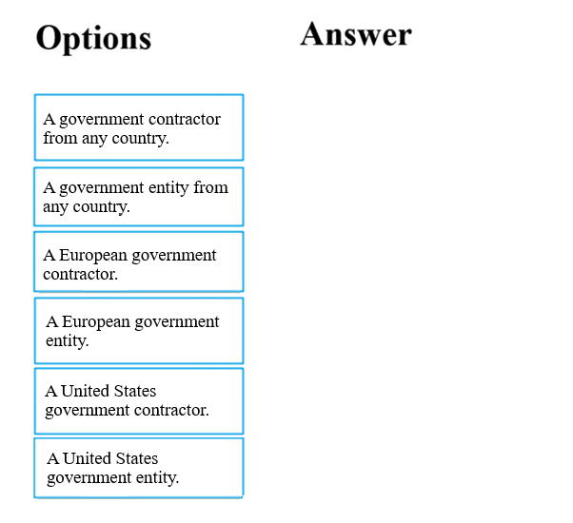
Hide Solution Discussion 28
Correct Answer: 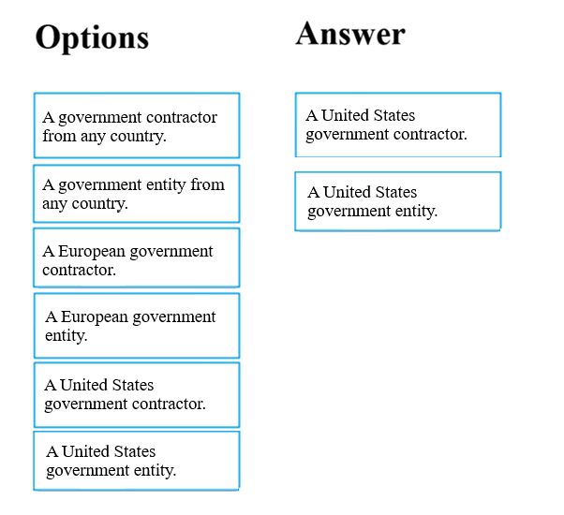
References:
https://docs.microsoft.com/en-us/learn/modules/intro-to-azure-government/2-what-is-azure-government
Question #29Topic 1
Note: The question is included in a number of questions that depicts the identical set-up. However, every question has a distinctive result. Establish if the solution satisfies the requirements.
Your company has an Azure Active Directory (Azure AD) environment. Users occasionally connect to Azure AD via the Internet.
You have been tasked with making sure that users who connect to Azure AD via the internet from an unidentified IP address, are automatically encouraged to change passwords.
Solution: You configure the use of Azure AD Identity Protection.
Does the solution meet the goal?
- A. Yes
- B. No
Hide Solution Discussion 20
Correct Answer: A 🗳️
References:
https://docs.microsoft.com/en-us/azure/active-directory/identity-protection/howto-sign-in-risk-policy
Community vote distribution
A (100%)
Question #30Topic 1
Note: The question is included in a number of questions that depicts the identical set-up. However, every question has a distinctive result. Establish if the solution satisfies the requirements.
Your company has an Azure Active Directory (Azure AD) environment. Users occasionally connect to Azure AD via the Internet.
You have been tasked with making sure that users who connect to Azure AD via the internet from an unidentified IP address, are automatically encouraged to change passwords.
Solution: You configure the use of Azure AD Privileged Identity Management.
Does the solution meet the goal?
- A. Yes
- B. No
Hide Solution Discussion 9
Correct Answer: B 🗳️
References:
https://docs.microsoft.com/en-us/azure/active-directory/identity-protection/howto-sign-in-risk-policy

Question #31Topic 1
Note: The question is included in a number of questions that depicts the identical set-up. However, every question has a distinctive result. Establish if the solution satisfies the requirements.
You are planning a strategy to deploy numerous web servers and database servers to Azure.
This strategy should allow for connection types between the web servers and database servers to be controlled.
Solution: You include network security groups (NSGs) in your strategy.
Does the solution meet the goal?
- A. Yes Most Voted
- B. No
Hide Solution Discussion 34
Correct Answer: A 🗳️
Community vote distribution
A (88%)
13%
Question #32Topic 1
Note: The question is included in a number of questions that depicts the identical set-up. However, every question has a distinctive result. Establish if the solution satisfies the requirements.
You are planning a strategy to deploy numerous web servers and database servers to Azure.
This strategy should allow for connection types between the web servers and database servers to be controlled.
Solution: You include a local network gateway in your strategy.
Does the solution meet the goal?
- A. Yes
- B. No Most Voted
Hide Solution Discussion 20
Correct Answer: B 🗳️
Community vote distribution
B (100%)
Question #33Topic 1
Note: The question is included in a number of questions that depicts the identical set-up. However, every question has a distinctive result. Establish if the solution satisfies the requirements.
Your company's Active Directory forest includes thousands of user accounts.
You have been informed that all network resources will be migrated to Azure. Thereafter, the on-premises data center will be retired.
You are required to employ a strategy that reduces the effect on users, once the planned migration has been completed.
Solution: You plan to require Azure Multi-Factor Authentication (MFA).
Does the solution meet the goal?
- A. Yes
- B. No Most Voted
Hide Solution Discussion 223
Correct Answer: A 🗳️
Community vote distribution
B (99%)
1%
Question #34Topic 1
HOTSPOT -
For each of the following statements, select Yes if the statement is true. Otherwise, select No.
NOTE: Each correct selection is worth one point.
Hot Area:
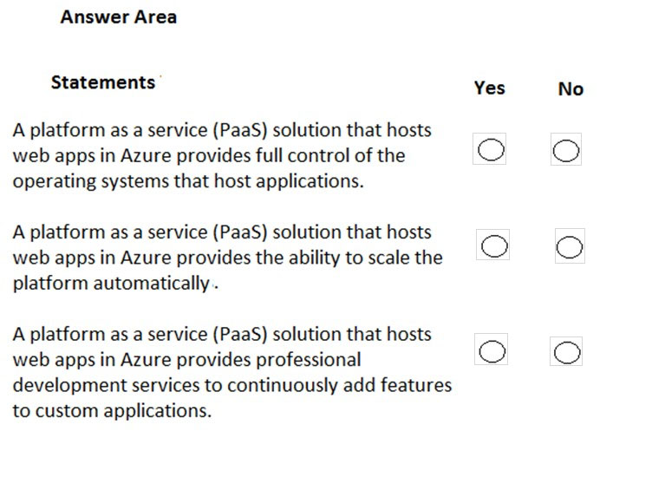
Hide Solution Discussion 132
Correct Answer: 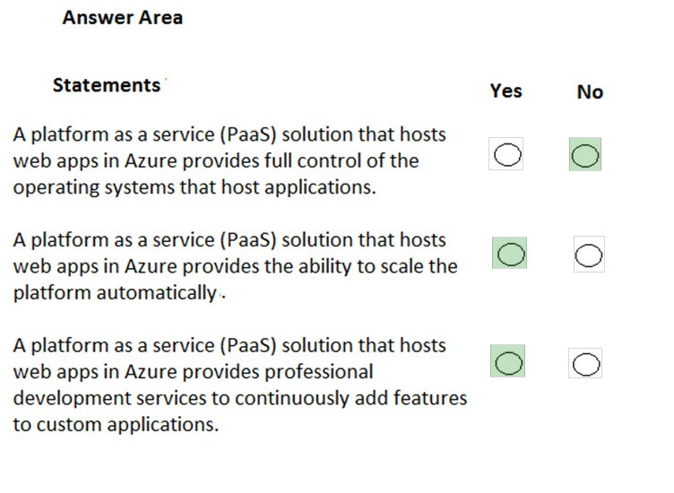
Box 1: No -
A PaaS solution does not provide access to the operating system. The Azure Web Apps service provides an environment for you to host your web applications.
Behind the scenes, the web apps are hosted on virtual machines running IIS. However, you have no direct access to the virtual machine, the operating system or
IIS.
Box 2: Yes -
A PaaS solution that hosts web apps in Azure does provide the ability to scale the platform automatically. This is known as autoscaling. Behind the scenes, the web apps are hosted on virtual machines running IIS. Autoscaling means adding more load balanced virtual machines to host the web apps.
Box 3: Yes -
PaaS provides a framework that developers can build upon to develop or customize cloud-based applications. PaaS development tools can cut the time it takes to code new apps with pre-coded application components built into the platform, such as workflow, directory services, security features, search and so on.
References:
https://azure.microsoft.com/en-gb/overview/what-is-paas/
Question #35Topic 1
HOTSPOT -
For each of the following statements, select Yes if the statement is true. Otherwise, select No.
NOTE: Each correct selection is worth one point.
Hot Area:
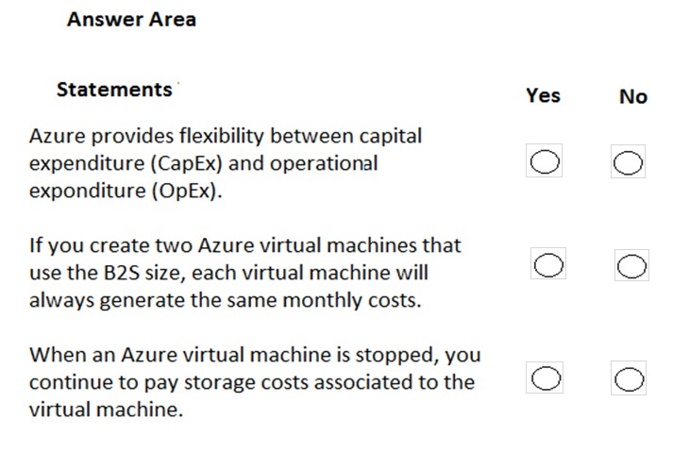
Hide Solution Discussion 85
Correct Answer: 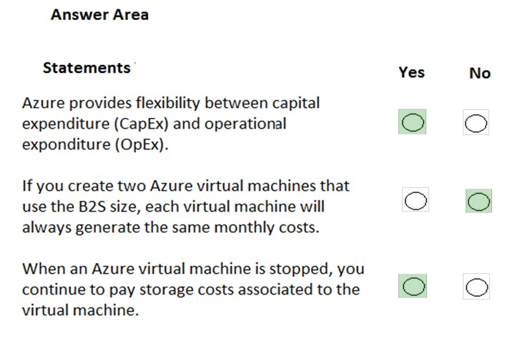
Box 1: Yes -
Traditionally, IT expenses have been considered a Capital Expenditure (CapEx). Today, with the move to the cloud and the pay-as-you-go model, organizations have the ability to stretch their budgets and are shifting their IT CapEx costs to Operating Expenditures (OpEx) instead. This flexibility, in accounting terms, is now an option due to the ג€as a Serviceג€ model of purchasing software, cloud storage and other IT related resources.
Box 2: No -
Two virtual machines using the same size could have different disk configurations. Therefore, the monthly costs could be different.
Box 3: Yes -
When an Azure virtual machine is stopped, you don't pay for the virtual machine. However, you do still pay for the storage costs associated to the virtual machine.
The most common storage costs are for the disks attached to the virtual machines. There are also other storage costs associated with a virtual machine such as storage for diagnostic data and virtual machine backups.
References:
https://meritsolutions.com/capex-vs-opex-cloud-computing-blog/
Question #36Topic 1
HOTSPOT -
To complete the sentence, select the appropriate option in the answer area.
Hot Area:
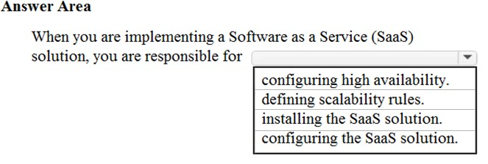
Hide Solution Discussion 44
Correct Answer: 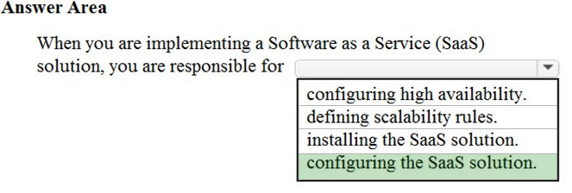
When you are implementing a Software as a Service (SaaS) solution, you are responsible for configuring the SaaS solution. Everything else is managed by the cloud provider.
SaaS requires the least amount of management. The cloud provider is responsible for managing everything, and the end user just uses the software.
Software as a service (SaaS) allows users to connect to and use cloud-based apps over the Internet. Common examples are email, calendaring and office tools
(such as Microsoft Office 365).
SaaS provides a complete software solution which you purchase on a pay-as-you-go basis from a cloud service provider. You rent the use of an app for your organization and your users connect to it over the Internet, usually with a web browser. All of the underlying infrastructure, middleware, app software and app data are located in the service provider's data center. The service provider manages the hardware and software and with the appropriate service agreement, will ensure the availability and the security of the app and your data as well.
Reference:
https://azure.microsoft.com/en-in/overview/what-is-saas/
https://docs.microsoft.com/en-gb/learn/modules/principles-cloud-computing/5-types-of-cloud-services
Question #37Topic 1
You have an on-premises network that contains several servers.
You plan to migrate all the servers to Azure.
You need to recommend a solution to ensure that some of the servers are available if a single Azure data center goes offline for an extended period.
What should you include in the recommendation?
- A. fault tolerance Most Voted
- B. elasticity
- C. scalability
- D. low latency
Hide Solution Discussion 54
Correct Answer: A 🗳️
Fault tolerance is the ability of a system to continue to function in the event of a failure of some of its components.
In this question, you could have servers that are replicated across datacenters.
Availability zones expand the level of control you have to maintain the availability of the applications and data on your VMs. Availability Zones are unique physical locations within an Azure region. Each zone is made up of one or more datacenters equipped with independent power, cooling, and networking. To ensure resiliency, there are a minimum of three separate zones in all enabled regions. The physical separation of Availability Zones within a region protects applications and data from datacenter failures.
With Availability Zones, Azure offers industry best 99.99% VM uptime SLA. By architecting your solutions to use replicated VMs in zones, you can protect your applications and data from the loss of a datacenter. If one zone is compromised, then replicated apps and data are instantly available in another zone.
References:
https://docs.microsoft.com/en-us/azure/virtual-machines/windows/manage-availability
Community vote distribution
A (100%)
Question #38Topic 1
HOTSPOT -
To complete the sentence, select the appropriate option in the answer area.
Hot Area:
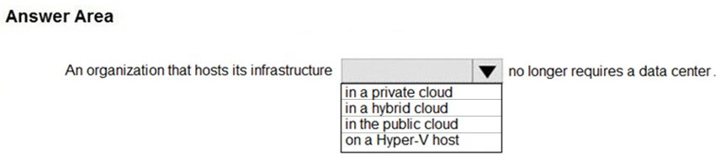
Hide Solution Discussion 42
Correct Answer: 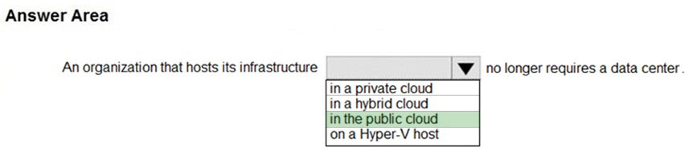
A private cloud is hosted in your datacenter. Therefore, you cannot close your datacenter if you are using a private cloud.
A public cloud is hosted externally, for example, in Microsoft Azure. An organization that hosts its infrastructure in a public cloud can close its data center.
Public cloud is the most common deployment model. In this case, you have no local hardware to manage or keep up-to-date ג€" everything runs on your cloud provider's hardware.
Microsoft Azure is an example of a public cloud provider.
In a private cloud, you create a cloud environment in your own datacenter and provide self-service access to compute resources to users in your organization.
This offers a simulation of a public cloud to your users, but you remain completely responsible for the purchase and maintenance of the hardware and software services you provide.
Reference:
https://docs.microsoft.com/en-gb/learn/modules/principles-cloud-computing/4-cloud-deployment-models
Question #39Topic 1
What are two characteristics of the public cloud? Each correct answer presents a complete solution.
NOTE: Each correct selection is worth one point.
- A. dedicated hardware
- B. unsecured connections
- C. limited storage
- D. metered pricing Most Voted
- E. self-service management Most Voted
Hide Solution Discussion 70
Correct Answer: DE 🗳️
With the public cloud, you get pay-as-you-go pricing ג€" you pay only for what you use, no CapEx costs.
With the public cloud, you have self-service management. You are responsible for the deployment and configuration of the cloud resources such as virtual machines or web sites. The underlying hardware that hosts the cloud resources is managed by the cloud provider.
Incorrect Answers:
A: You don't have dedicated hardware. The underlying hardware is shared so you could have multiple customers using cloud resources hosted on the same physical hardware.
B: Connections to the public cloud are secure.
C: Storage is not limited. You can have as much storage as you like.
References:
https://docs.microsoft.com/en-gb/learn/modules/principles-cloud-computing/4-cloud-deployment-models
Community vote distribution
DE (100%)
Question #40Topic 1
HOTSPOT -
To complete the sentence, select the appropriate option in the answer area.
Hot Area:
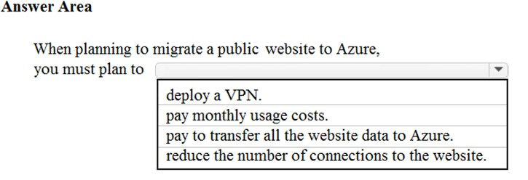
Hide Solution Discussion 48
Correct Answer: 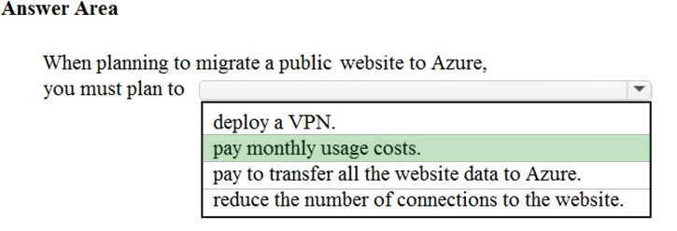
When planning to migrate a public website to Azure, you must plan to pay monthly usage costs. This is because Azure uses the pay-as-you-go model.

Question #41Topic 1
Note: This question is part of a series of questions that present the same scenario. Each question in the series contains a unique solution that might meet the stated goals. Some question sets might have more than one correct solution, while others might not have a correct solution.
After you answer a question in this section, you will NOT be able to return to it. As a result, these questions will not appear in the review screen.
Your company plans to migrate all its data and resources to Azure.
The company's migration plan states that only Platform as a Service (PaaS) solutions must be used in Azure.
You need to deploy an Azure environment that meets the company migration plan.
Solution: You create an Azure App Service and Azure SQL databases.
Does this meet the goal?
- A. Yes Most Voted
- B. No
Hide Solution Discussion 44
Correct Answer: A 🗳️
Azure App Service and Azure SQL databases are examples of Azure PaaS solutions. Therefore, this solution does meet the goal.
Community vote distribution
A (93%)
7%
Question #42Topic 1
Note: This question is part of a series of questions that present the same scenario. Each question in the series contains a unique solution that might meet the stated goals. Some question sets might have more than one correct solution, while others might not have a correct solution.
After you answer a question in this section, you will NOT be able to return to it. As a result, these questions will not appear in the review screen.
Your company plans to migrate all its data and resources to Azure.
The company's migration plan states that only Platform as a Service (PaaS) solutions must be used in Azure.
You need to deploy an Azure environment that meets the company migration plan.
Solution: You create an Azure App Service and Azure virtual machines that have Microsoft SQL Server installed.
Does this meet the goal?
- A. Yes
- B. No Most Voted
Hide Solution Discussion 186
Correct Answer: A 🗳️
Azure App Service is a PaaS (Platform as a Service) service. Azure virtual machines are an IaaS (Infrastructure as a Service) service, and a Paas service.
Therefore, this solution does meet the goal.
Note: Like IaaS, PaaS includes infrastructureג€"servers, storage, and networkingג€"but also middleware, development tools, business intelligence (BI) services, database management systems, and more. PaaS is designed to support the complete web application lifecycle: building, testing, deploying, managing, and updating.
Reference:
https://azure.microsoft.com/en-us/overview/what-is-paas/
Community vote distribution
B (92%)
8%
Question #43Topic 1
Note: This question is part of a series of questions that present the same scenario. Each question in the series contains a unique solution that might meet the stated goals. Some question sets might have more than one correct solution, while others might not have a correct solution.
After you answer a question in this section, you will NOT be able to return to it. As a result, these questions will not appear in the review screen.
Your company plans to migrate all its data and resources to Azure.
The company's migration plan states that only Platform as a Service (PaaS) solutions must be used in Azure.
You need to deploy an Azure environment that meets the company migration plan.
Solution: You create an Azure App Service and Azure Storage accounts.
Does this meet the goal?
- A. Yes Most Voted
- B. No Most Voted
Hide Solution Discussion 219
Correct Answer: B 🗳️
Community vote distribution
B (55%)
A (45%)
Question #44Topic 1
Your company hosts an accounting application named App1 that is used by all the customers of the company.
App1 has low usage during the first three weeks of each month and very high usage during the last week of each month.
Which benefit of Azure Cloud Services supports cost management for this type of usage pattern?
- A. high availability
- B. high latency
- C. elasticity Most Voted
- D. load balancing
Hide Solution Discussion 74
Correct Answer: C 🗳️
Elasticity in this case is the ability to provide additional compute resource when needed and reduce the compute resource when not needed to reduce costs.
Autoscaling is an example of elasticity.
Elastic computing is the ability to quickly expand or decrease computer processing, memory and storage resources to meet changing demands without worrying about capacity planning and engineering for peak usage. Typically controlled by system monitoring tools, elastic computing matches the amount of resources allocated to the amount of resources actually needed without disrupting operations. With cloud elasticity, a company avoids paying for unused capacity or idle resources and doesn't have to worry about investing in the purchase or maintenance of additional resources and equipment.
References:
https://azure.microsoft.com/en-gb/overview/what-is-elastic-computing/
Community vote distribution
C (88%)
13%
Question #45Topic 1
You plan to migrate a web application to Azure. The web application is accessed by external users.
You need to recommend a cloud deployment solution to minimize the amount of administrative effort used to manage the web application.
What should you include in the recommendation?
- A. Software as a Service (SaaS)
- B. Platform as a Service (PaaS) Most Voted
- C. Infrastructure as a Service (IaaS)
- D. Database as a Service (DaaS)
Hide Solution Discussion 80
Correct Answer: B 🗳️
Azure App Service is a platform-as-a-service (PaaS) offering that lets you create web and mobile apps for any platform or device and connect to data anywhere, in the cloud or on-premises. App Service includes the web and mobile capabilities that were previously delivered separately as Azure Websites and Azure Mobile
Services.
References:
https://docs.microsoft.com/en-us/azure/security/fundamentals/paas-applications-using-app-services
Community vote distribution
B (78%)
A (22%)
Question #46Topic 1
HOTSPOT -
Which cloud deployment solution is used for Azure virtual machines and Azure SQL databases? To answer, select the appropriate options in the answer area.
NOTE: Each correct selection is worth one point.
Hot Area:
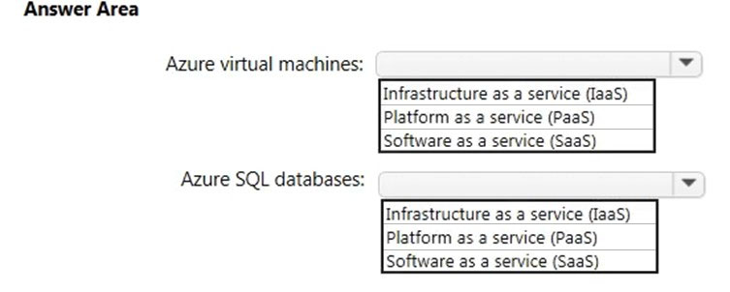
Hide Solution Discussion 103
Correct Answer: 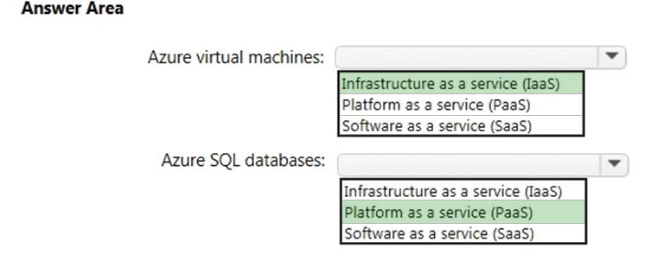
Box 1:
Azure virtual machines are Infrastructure as a Service (IaaS).
Infrastructure as a Service is the most flexible category of cloud services. It aims to give you complete control over the hardware that runs your application (IT infrastructure servers and virtual machines (VMs), storage, networks, and operating systems). Instead of buying hardware, with IaaS, you rent it.
Box 2:
Azure SQL databases are Platform as a Service (Paas).
Azure SQL Database is a fully managed Platform as a Service (PaaS) Database Engine that handles most of the database management functions such as upgrading, patching, backups, and monitoring without user involvement. Azure SQL Database is always running on the latest stable version of SQL Server
Database Engine and patched OS with 99.99% availability. PaaS capabilities that are built-in into Azure SQL database enable you to focus on the domain specific database administration and optimization activities that are critical for your business.
Reference:
https://docs.microsoft.com/en-gb/learn/modules/principles-cloud-computing/5-types-of-cloud-services https://docs.microsoft.com/en-us/azure/sql-database/sql-database-paas-index
Question #47Topic 1
You have an on-premises network that contains 100 servers.
You need to recommend a solution that provides additional resources to your users. The solution must minimize capital and operational expenditure costs.
What should you include in the recommendation?
- A. a complete migration to the public cloud
- B. an additional data center
- C. a private cloud
- D. a hybrid cloud Most Voted
Hide Solution Discussion 427
Correct Answer: D 🗳️
A hybrid cloud is a combination of a private cloud and a public cloud.
Capital expenditure is the spending of money up-front for infrastructure such as new servers.
With a hybrid cloud, you can continue to use the on-premises servers while adding new servers in the public cloud (Azure for example). Adding new servers in
Azure minimizes the capital expenditure costs as you are not paying for new servers as you would if you deployed new server on-premises.
Incorrect Answers:
A: A complete migration of 100 servers to the public cloud would involve a lot of operational expenditure (the cost of migrating all the servers).
B: An additional data center would involve a lot of capital expenditure (the cost of the new infrastructure).
C: A private cloud is hosted on on-premises servers to this would involve a lot of capital expenditure (the cost of the new infrastructure to host the private cloud).
Reference:
https://docs.microsoft.com/en-gb/learn/modules/principles-cloud-computing/4-cloud-deployment-models
Community vote distribution
D (88%)
13%
Question #48Topic 1
HOTSPOT -
For each of the following statements, select Yes if the statement is true. Otherwise, select No.
NOTE: Each correct selection is worth one point.
Hot Area:
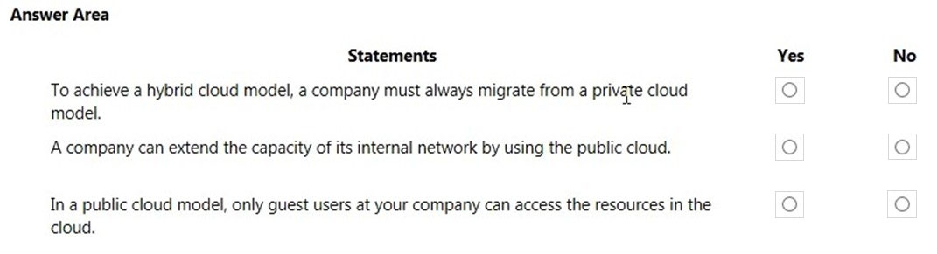
Hide Solution Discussion 86
Correct Answer: 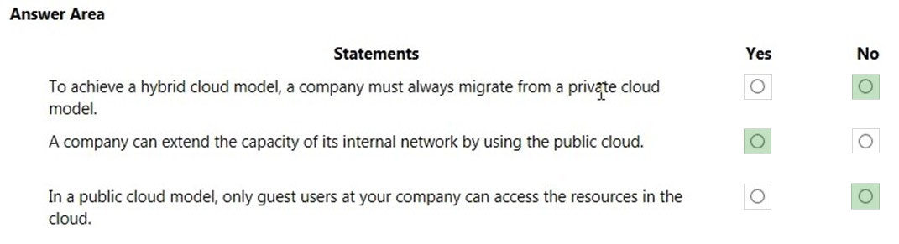
Box 1: No -
It is not true that a company must always migrate from a private cloud model to implement a hybrid cloud. You could start with a public cloud and then combine that with an on-premise infrastructure to implement a hybrid cloud.
Box 2: Yes -
A company can extend the capacity of its internal network by using the public cloud. This is very common. When you need more capacity, rather than pay out for new on-premises infrastructure, you can configure a cloud environment and connect your on-premises network to the cloud environment by using a VPN.
Box 3: No -
It is not true that only guest users can access cloud resources. You can give anyone with an account in Azure Active Directory access to the cloud resources.
There are many authentication scenarios but a common one is to replicate your on-premises Active Directory accounts to Azure Active Directory and provide access to the Azure Active Directory accounts. Another commonly used authentication method is 'Federation' where authentication for access to cloud resources is passed to another authentication provider such as an on-premises Active Directory. https://azure.microsoft.com/en-gb/overview/what-is-hybrid-cloud-computing/
Question #49Topic 1
You plan to migrate several servers from an on-premises network to Azure.
What is an advantage of using a public cloud service for the servers over an on-premises network?
- A. The public cloud is owned by the public, NOT a private corporation
- B. The public cloud is a crowd-sourcing solution that provides corporations with the ability to enhance the cloud
- C. All public cloud resources can be freely accessed by every member of the public
- D. The public cloud is a shared entity whereby multiple corporations each use a portion of the resources in the cloud Most Voted
Hide Solution Discussion 44
Correct Answer: D 🗳️
The public cloud is a shared entity whereby multiple corporations each use a portion of the resources in the cloud. The hardware resources (servers, infrastructure etc.) are managed by the cloud provider. Multiple companies create resources such as virtual machines and virtual networks on the hardware resources.
Incorrect Answers:
A: The public cloud is not owned by the public. In the case of Microsoft Azure, the cloud is owned by Microsoft.
B: The public cloud is a not crowd-sourcing solution. In the case of Microsoft Azure, the cloud is owned by Microsoft.
C: It is not true that public cloud resources can be freely accessed by every member of the public. You pay for a cloud subscription and create accounts for your users to access your cloud resources. No one can access your cloud resources until you create user accounts and provide the appropriate access permissions.
Community vote distribution
D (83%)
C (17%)
Question #50Topic 1
HOTSPOT -
To complete the sentence, select the appropriate option in the answer area.
Hot Area:
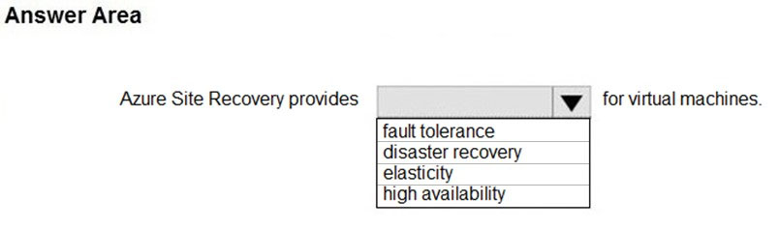
Hide Solution Discussion 257
Correct Answer: 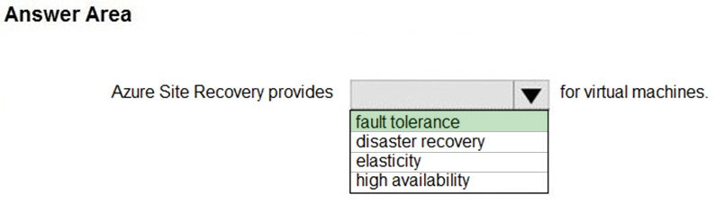
Azure Site Recovery helps ensure business continuity by keeping business apps and workloads running during outages. Site Recovery replicates workloads running on physical and virtual machines (VMs) from a primary site to a secondary location.
Reference:
https://docs.microsoft.com/en-us/azure/site-recovery/site-recovery-overview

